I1905050 – Repacorp Freight Item Documentation
ActiveM_Repacorp_Seth on SQL19
- Freight Categories
Fig. 1
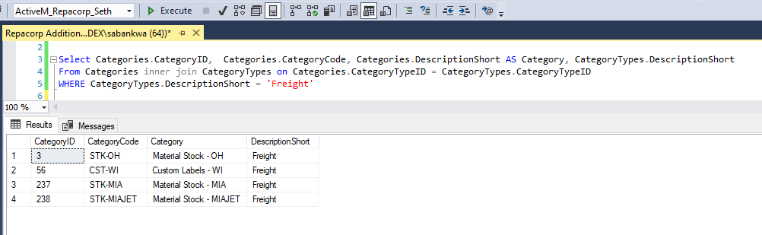

- Shippable Items
Select these items on sales order will automatically create freight charges when invoiced from a shipment.
Fig. 2
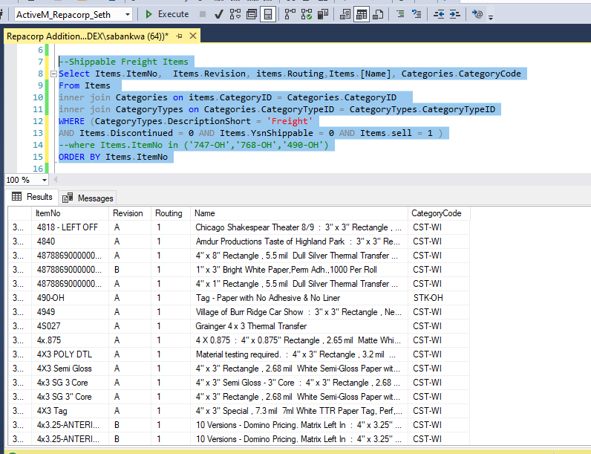

- To setup item 490-OH whose category is STK-OH as per fig 2 for example, See below.

Fig. 3. Utilities |Userdefined Setup
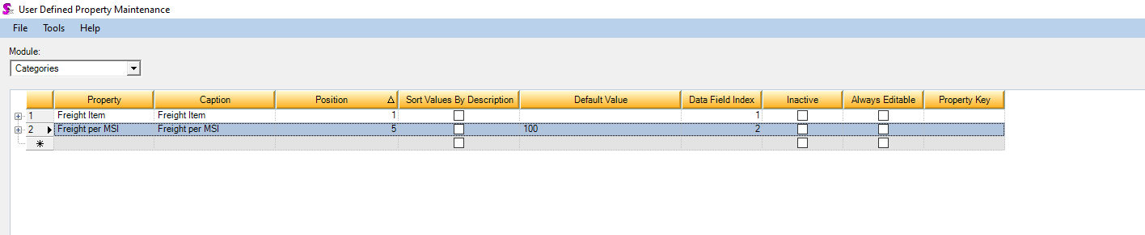
Ensure you have a Freight Item Category.
View properties on Freight Item and create a lookup sql to retrieve the freight items.
And set up the Userdefined Item Lookup SQL property for the freight category
Fig. 4
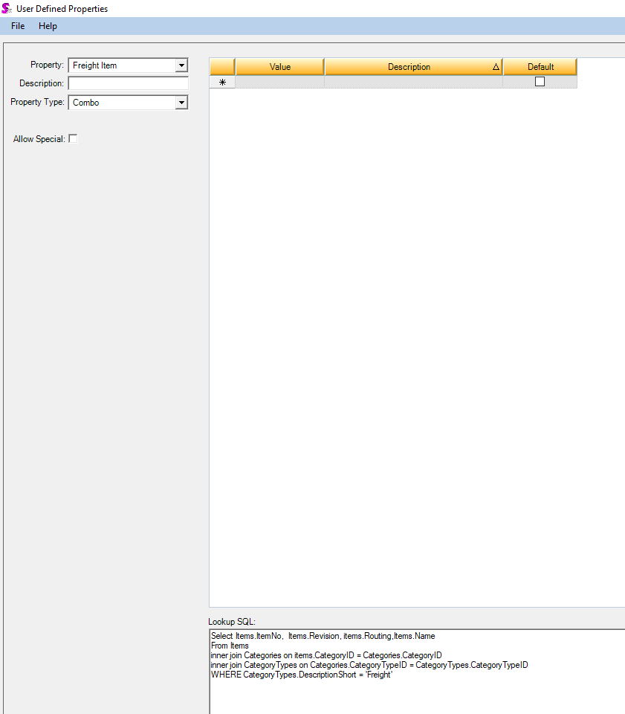
Select Items.ItemNo, Items.Revision, items.Routing,Items.Name
From Items
inner join Categories on items.CategoryID = Categories.CategoryID
inner join CategoryTypes on Categories.CategoryTypeID = CategoryTypes.CategoryTypeID
WHERE CategoryTypes.DescriptionShort = 'Freight'
- Complete your setup.

After setting up the Userdefined Item Lookup SQL property for the freight category, You will now setup the prices for each freight category in step 1. Example for STK-OH
The Lookup Sql you set up in step 3, fig 4, is what loads the freight item drop down below.
Enter the Price for that freight Category. These values are saved to the Userdefineds 1 and 2 fields of the AdditionalValues table for the Categories module and this CategoryID.

The price is used in the view that provides the data from module setup table. See the database objects setup for the view for the freight items.
Fig. 5
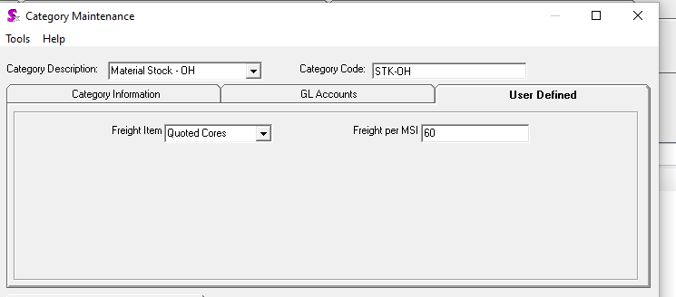
See below, copy and run the scripts below to setup the database objects

Database Objects Setup
1. User defined function GetInvoiceTaxes. Calculates Taxes for an invoice
SET ANSI_NULLS ON
GO
SET QUOTED_IDENTIFIER ON
GO

CREATE FUNCTION [dbo].[ufn_GetInvoiceTaxes]
(
@InvoiceID INT,
@InvoiceDetailID INT
)
RETURNS

@Table_Var TABLE
(
InvoiceID INT,
InvoiceDetailID INT,
Code NVARCHAR(50),
LineTax float,
ExtendedPrice float,
TotalTaxes float,
SubTotal float,
Rate float
)
AS

BEGIN

DECLARE @TaxData AS Table(OwnerID INT, OwnerDetailID INT, RuleDescJson NVARCHAR(MAX))

INSERT INTO @TaxData(OwnerID, OwnerDetailID, RuleDescJson)
SELECT InvoiceID, InvoiceDetailID, CASE WHEN NULLIF(RuleDesc, '') IS NULL THEN '' ELSE Replace(Replace(REPLACE(RuleDesc,',',''),'|','}},{"TaxDetail": {"OwnerID":' + CONVERT(VARCHAR(10),InvoiceID) +',"Code":"'),'=','", "LineTax":') + '}}' END
FROM InvoiceDetails
where (InvoiceDetailID = @InvoiceDetailID)

Declare @val Varchar(MAX)
SELECT @val = dbo.concatenate(CASE WHEN RuleDescJson <> '' THEN RIGHT(RuleDescJson, CASE WHEN RuleDescJson <> '' THEN LEN(RuleDescJson)-3 ELSE 0 END) ELSE '' END) FROM @TaxData

Insert INTO @Table_Var(InvoiceID, InvoiceDetailID, Code, LineTax, ExtendedPrice, TotalTaxes, SubTotal, Rate)
SELECT InvoiceDetails.InvoiceID, InvoiceDetails.InvoiceDetailID, Code, SUM(LineTax) AS LineTax, InvoiceDetails.ExtendedPrice, Invoice.TotalTaxes, Invoice.SubTotal, SUM(LineTax)/Invoice.SubTotal * 100
FROM InvoiceDetails
LEFT JOIN OPENJSON ( '[' + @val +']' )
WITH (
OwnerID INT '$.TaxDetail.OwnerID' ,
Code varchar(255) '$.TaxDetail.Code' ,
LineTax DECIMAL(38,14) '$.TaxDetail.LineTax'
) AS Tax
ON InvoiceDetails.InvoiceID = Tax.OwnerID
INNER JOIN Invoice ON InvoiceDetails.InvoiceID = Invoice.InvoiceID
WHERE InvoiceDetails.InvoiceID = @InvoiceID AND InvoiceDetails.InvoiceDetailID = @InvoiceDetailID
GROUP BY InvoiceDetails.InvoiceID, InvoiceDetails.InvoiceDetailID, Code, InvoiceDetails.ExtendedPrice, Invoice.TotalTaxes, Invoice.SubTotal

RETURN
END
2. Database View view_FreightItems.
Business rules for freight item selections and pricing, as per design document

USE [ActiveM_Repacorp_Seth]
GO
SET ANSI_NULLS ON
GO
SET QUOTED_IDENTIFIER ON
GO

ALTER VIEW [dbo].[view_FreightItems]
AS

SELECT DISTINCT FreightItem.ItemID, CASE WHEN SHCount.RecCount > 1 THEN 'BCTEST_F00' ELSE additionalinfo.userdefined1 END AS ItemNo, 'A' AS Revision, '1' AS Routing, 1 AS Qty,
CASE ISNULL(Additionalinfo.Userdefined2, 0) WHEN 0 THEN CONVERT(float, ISNULL(shipping.freightcosts,0)) ELSE CONVERT(float, Additionalinfo.Userdefined2) END AS ListPrice,
shipping.ShippingID, shipping.ShippingNo, Invoice.InvoiceID, Invoice.InvoiceNo
FROM Items INNER JOIN ShippingDetails ON items.itemid = ShippingDetails.itemId INNER JOIN shipping ON ShippingDetails.ShippingID = shipping.ShippingID
INNER JOIN ShipTerms ON ShippingDetails.ShipTermID = ShipTerms.ShipTermID
LEFT JOIN InvoiceDetails ON InvoiceDetails.ShippingDetailID = ShippingDetails.ShippingDetailID
LEFT JOIN Invoice ON InvoiceDetails.InvoiceID = Invoice.InvoiceID
INNER JOIN Categories ON items.CategoryID = Categories.CategoryID LEFT JOIN CategoryTypes ON Categories.CategoryTypeID = CategoryTypes.CategoryTypeID
LEFT JOIN additionalinfo ON Categories.CategoryID = additionalinfo.OwnerID AND additionalinfo.ModuleID = 74
LEFT JOIN (SELECT DataInfo.ShippingID, COUNT(DataInfo.ShippingID) AS RecCount
FROM (SELECT shipping.ShippingID, Categories.CategoryID
FROM Items INNER JOIN ShippingDetails ON items.itemid = ShippingDetails.itemId
INNER JOIN shipping ON ShippingDetails.ShippingID = shipping.ShippingID
INNER JOIN ShipTerms ON ShippingDetails.ShipTermID = ShipTerms.ShipTermID
LEFT JOIN InvoiceDetails ON InvoiceDetails.ShippingDetailID = ShippingDetails.ShippingDetailID
LEFT JOIN Invoice ON InvoiceDetails.InvoiceID = Invoice.InvoiceID
INNER JOIN Categories ON items.CategoryID = Categories.CategoryID
LEFT JOIN CategoryTypes ON Categories.CategoryTypeID = CategoryTypes.CategoryTypeID
WHERE ShipTerms.ShipTermsCode = 'COL' AND (shipping.ShippingID > 377107)
GROUP BY shipping.ShippingID, Categories.CategoryID) AS DataInfo
GROUP BY DataInfo.ShippingID) AS SHCount
ON shipping.ShippingID = SHCount.ShippingID
LEFT JOIN dbo.Items AS FreightItem ON CASE WHEN SHCount.RecCount > 1 THEN 'BCTest_F00' ELSE additionalinfo.userdefined1 END = FreightItem.ItemNo AND FreightItem.Revision = 'A' AND FreightItem.Routing = '1' AND additionalinfo.ModuleID = 74
WHERE ShipTerms.ShipTermsCode = 'COL'
GO

3. Table Trigger InvoiceUpdateFromExternalShipData
Triggered by changing the current price in the custom ShippingDataExport UPS table.
And updates the freight item prices and totals in the Invoice tables.
SET ANSI_NULLS ON
GO

SET QUOTED_IDENTIFIER ON
GO

ALTER TRIGGER [dbo].[InvoiceUpdateFromExternalShipData]
ON [dbo].[ShippingDataExport]
AFTER INSERT, UPDATE
AS
BEGIN
SET NOCOUNT ON;

declare @InvoiceID int
declare @InvoiceDetailID int
declare @newPrice float;
declare @newBillOfLading VARCHAR(50);
declare
@Table_Taxes TABLE
(
InvoiceID INT,
InvoiceDetailID INT,
Code NVARCHAR(50),
LineTax float,
ExtendedPrice float,
TotalTaxes float,
SubTotal float,
Rate float
)

--1. Get Invoice line data
---------------------------------------------------------------------------------------------------
SELECT TOP 1 @InvoiceID = InvoiceDetails.InvoiceID, @InvoiceDetailID = InvoiceDetails.InvoiceDetailID, @newPrice = inserted.FreightCosts, @newBillOfLading = inserted.BillofLading
FROM Inserted
INNER JOIN view_FreightItems ON Inserted.ShippingNo = view_FreightItems.ShippingNo
INNER JOIN Invoice ON view_FreightItems.InvoiceID = Invoice.InvoiceID
INNER JOIN InvoiceDetails ON Invoice.InvoiceID = InvoiceDetails.InvoiceID AND view_FreightItems.ItemID = InvoiceDetails.ItemID

if @InvoiceDetailID > 0
BEGIN
--2A. Get and store the Invoice the existing detail Taxes
---------------------------------------------------------------------
INSERT INTO @Table_Taxes(InvoiceID, InvoiceDetailID, Code, LineTax, ExtendedPrice,TotalTaxes, SubTotal, Rate)
select InvoiceID, InvoiceDetailID, Code, LineTax, ExtendedPrice,TotalTaxes, SubTotal, Rate
from dbo.[ufn_GetInvoiceTaxes](@InvoiceID, @InvoiceDetailID)

--2B. Build the rule desc and total taxes
--BEGIN
DECLARE @MyCursor CURSOR;
DECLARE @ruleDesc varchar(50) = '|';
DECLARE @ruleCode varchar(50);
DECLARE @ruletax float;
DECLARE @ruleRate float;
DECLARE @totalTaxes float;

SET @MyCursor = CURSOR FOR
select Code, Rate from dbo.[ufn_GetInvoiceTaxes](@InvoiceID, @InvoiceDetailID)

OPEN @MyCursor
FETCH NEXT FROM @MyCursor
INTO @ruleCode, @ruleRate

/* Build the rule desc and total taxes*/
WHILE @@FETCH_STATUS = 0
BEGIN
--------------------------------------
/* |AZ-PH=33.46|AZ=122.12 */
DECLARE @newRuleTax float;
SET @newRuleTax = ROUND( @ruleRate * @newPrice, 2);
SET @ruleDesc = @ruleDesc + @ruleCode + '=' + @newRuleTax
SET @totalTaxes =@totalTaxes + @newRuleTax
----------------------------------------------------
FETCH NEXT FROM @MyCursor
INTO @ruleCode, @ruleRate
END;

CLOSE @MyCursor ;
DEALLOCATE @MyCursor;
--END; 2B.

--3. update Invoice details
---------------------------------------------------------------------
UPDATE InvoiceDetails
SET
InvoiceDetails.UnitPrice = @newPrice, --Inserted.FreightCosts,
InvoiceDetails.NetPrice = @newPrice,
InvoiceDetails.ExtendedPrice = @newPrice, --Inserted.FreightCosts,
InvoiceDetails.RuleDesc = @ruleDesc,
InvoiceDetails.TotalTaxes = @totalTaxes
WHERE InvoiceDetails.InvoiceDetailID = @InvoiceDetailID

----4. update Invoice header
-----------------------------------------------------------------------
UPDATE Invoice
SET
Invoice.BillOfLading = @newBillOfLading, --Inserted.BillofLading,
Invoice.Freight = @newPrice,
Invoice.SubTotal = InvoiceDetails.SubTotal,
Invoice.TotalTaxes = InvoiceDetails.TotalTaxes
FROM Invoice
INNER JOIN
(SELECT InvoiceID, Sum(ExtendedPrice) AS SubTotal, Sum(TotalTaxes) AS TotalTaxes
FROM InvoiceDetails
WHERE InvoiceDetails.InvoiceID = @InvoiceID
GROUP BY InvoiceID) AS InvoiceDetails
ON Invoice.InvoiceID = InvoiceDetails.InvoiceID
WHERE InvoiceDetails.InvoiceID = @InvoiceID

END;
END
GO

4. Table Module Setup Records

SHIPPING – (Setup Code: AutoAddInvoiceDetail)
SELECT view_FreightItems.* FROM view_FreightItems
INNER JOIN Shipping ON view_FreightItems.ShippingID = Shipping.ShippingID

INVOICE (Setup Code: AutoAddInvoiceDetail_FromInvoice)
SELECT view_FreightItems.* FROM view_FreightItems
INNER JOIN Invoice ON view_FreightItems.InvoiceID = Invoice.InvoiceID

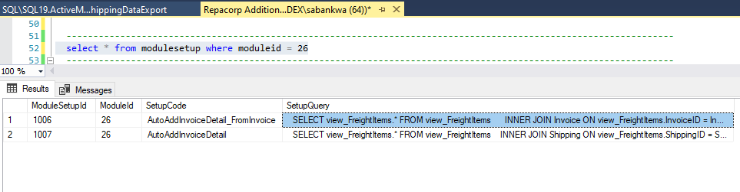

Invoicing a Shipment transaction
1. Create a Shipment from Sales Order and Invoice it.
Create a shipment from sales order with line items that belong to the freight categories setup.
Select a line item like 49-OH as shown in Fig. 1
--Shippable Freight Items
Select Items.ItemNo, Items.Revision, items.Routing,Items.[Name], Categories.CategoryCode
From Items inner join Categories on items.CategoryID = Categories.CategoryID
inner join CategoryTypes on Categories.CategoryTypeID = CategoryTypes.CategoryTypeID
WHERE (CategoryTypes.DescriptionShort = 'Freight'
AND Items.Discontinued = 0 AND Items.YsnShippable = 0 AND Items.sell = 1 )
ORDER BY Items.ItemNo

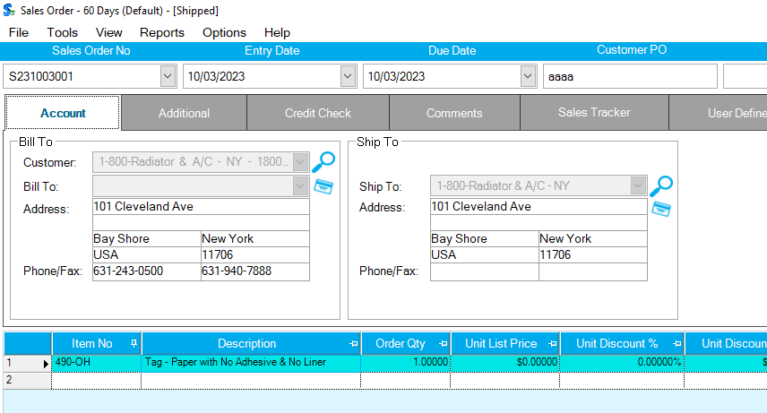
Now, generate the shipment.

2. Generate the Invoice from the shipment
Ship Term
Select the required line-item ship term as per design document
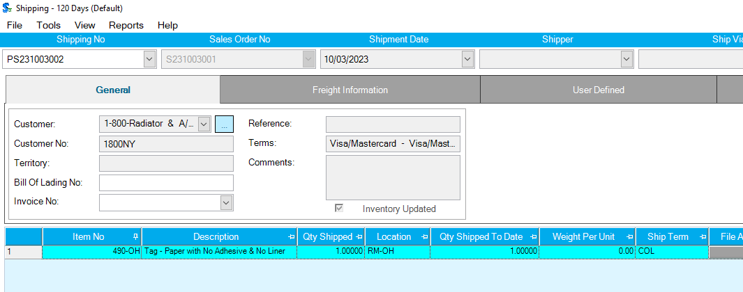
Select ‘COL’ as the ship term on the shipment detail
Generating an invoice should automatically add the 747-OH freight item based on the module setup query that references the view_freightItems view.

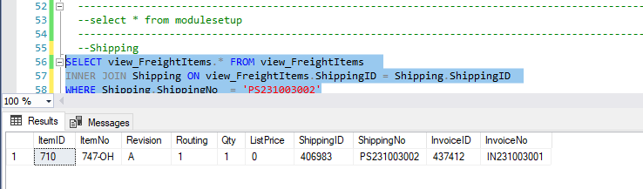

Now generate the invoice.

3. Invoice
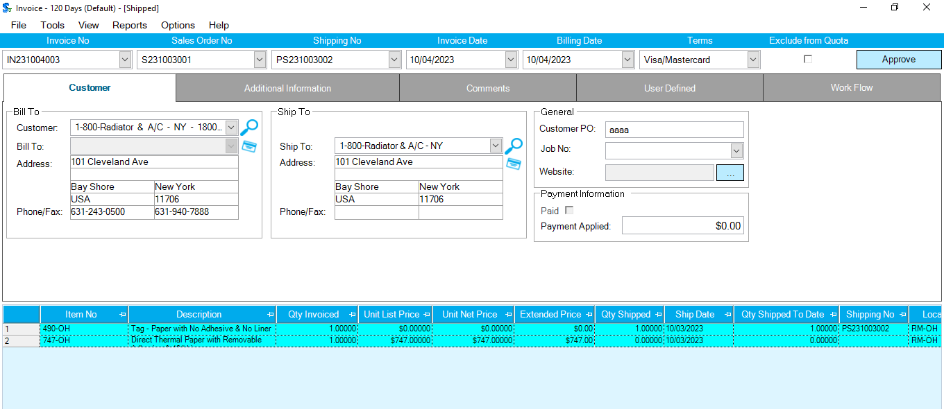

Note the ItemNo and ListPrice from AdditionalInfo Userdefined1 and 2. When Userdefined2 is 0, the Freight charges on the shipment header will be used.

4. TEST THE TRIGGER AND FUNCTIONS
To complete your testing, change the FreightCosts value in the ShippingDataExport table and refresh your invoice screen.
Your new freight cost should reflect on the invoice screen. The invoice freight detail pricing and header totals should be updated to reflect the new freight charges.

--TO TEST IN THE DATABASE

select * from shipping where shippingno = 'PS231003002' and get the ShippingID = 406983
select * from invoice where shippingid = 406983 and get the InvoiceID = 437416

update ShippingDataExport set FreightCosts = 100 where ShippingNo = 'PS231003002'
go; This should trigger the update.

select * from invoicedetails where invoiceid = 437416
go
select invoice.SubTotal, invoice.TotalTaxes from invoice where shippingid = 40698
go; to check the results.

